# PROJECT DEVELOPMENT PHASE SPRINT-III

|  |  |
| --- | --- |
| Date | 14 November 2022 |
| Team ID | PNT2022TMID38277 |
| Project Name | Natural Disaster Intensity Analysis and  Classification using Artificial Intelligence |

**DETECTION AND ANALYSIS OF DATA:**

After Testing and Training the model, data which given in dataset are analysed and visualised effectively to detect the Disaster Type. Using webcam, it can capture image or video stream of Disaster, to detect and analyse the type of Disaster.

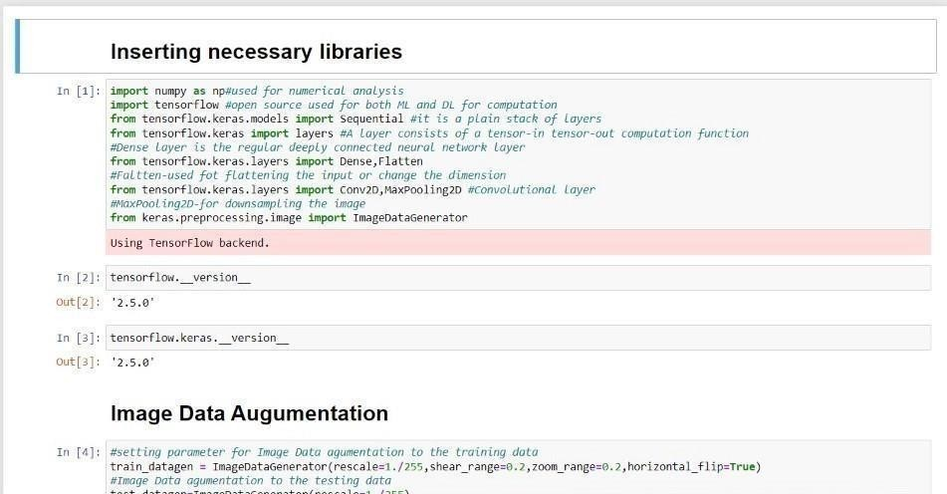

# MODEL BUILDING:

Building a Model with web application named “FLASK”, model building process consist several steps like,

* Import the model building Libraries
* Initializing the model
* Adding CNN Layers
* Adding Hidden Layer
* Adding Output Layer
* Configure the Learning Process
* Training and testing the model

all the above processes are done and saved in a model.

